Shabbos Stories for
Parshas ha’azinu 5782
Volume 13A, Issue 4 - 12 Tishrei/September 18, 2021
Printed L’illuy nishmas Nechama bas R’ Noach, a”h

For a free subscription, please forward your request to keren18@juno.com
Past stories can be found on the website ShabbosStories.com

A Most Heroic Fiancée
By Daniel Keren

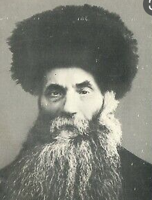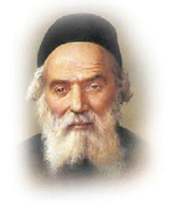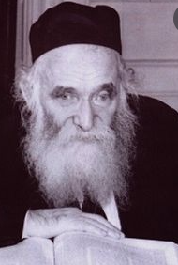
Rabbi Isser Zalman Meltzer, the Chofetz Chaim and Rabbi Aharon Kotler

Rabbi Dovid Ribiat recently told the story of Rabbi Isser Zalman Meltzer, zt”l, 1870-1953) who shortly after he became engaged to Baila Hinda, the daughter of the prominent Rav Shraga Feivel Frank discovered that he had a serious health issue and his doctors didn’t think that he would live another year. Rabbi Meltzer told his young fiancée that it wasn’t fair for him to hold her to the engagement under such conditions.
But Baila Hinda was so impressed by the spiritual purity of her chasan that she told her parents that she didn’t want to break the engagement even it meant that she would only be worthy to be married to Rabbi Meltzer for just a year. Her parents were not so sure that this was a wise decision by their daughter whom they loved verymuch. And finally it was agreed that the question of whether or not to continue the engagement should be brought to the gadol hador – the Chofetz Chaim (Rabbi Yisroel Meir Kagan, zt”l, 1838-1933).
The Chofetz Chaim responded that some people are healthy and other people have arichas yomim (long life) hinting that Rabbi Meltzer might never again be very healthy but would be destined to have a long life. As a result of that response Baila Hinda decided not to break the engagement and indeed they married and he merited to live to an old age of 83. He became a distinguished Marbitz Torah and Rosh Yeshiva.
Among their children was a daughter Rivka Chana Perel who married Rabbi Aharon Kotler, zt”l (1891-1962) and together they were the progenitors of the Kotler dynasty that continues to guide the world famous Beth Medrash Govoha Yeshiva in Lakewood to this day.

Reprinted from the July 23, 2021 edition of The Flatbush Jewish Journal.

The Unbelievable
Ibuprofen Tablets
By R.Y.

I left for Shacharis at 4:30 in the morning, first immersing in a mikveh and learning a little as usual. On the way, I saw a young man walking around in a dazed state. I wondered to myself, ‘What is he doing here so early in the morning? Maybe something happened!?’
I turned to the young man and asked if he needed help with something. He replied that his wife was suffering from a bad toothache, and she had an appointment with a dentist later in the day, but in the meantime, she is suffering and not sleeping.
I hurried home despite losing some of my preparation time, but the pain of a Jew is above everything (despite that it is not easy to change my daily routine), but when I took the first step, I do not know why, but I reached in my jacket pocket, and I felt something strange, and I took it out and it was some ibuprofen for pain. I could not believe what I was seeing, and I thought for a moment that Eliyahu HaNavi put the tablets in my pocket.

Hakodesh Baruch Hu was
Concerned for a Suffering Woman
A few seconds passed and I remembered what happened: Three weeks ago I had a root canal. The dentist gave me the pills in case I needed them. I did not need them. They stayed in my pocket for exactly three weeks for the moment when HaKadosh Baruch Hu decided to send a young man in the street to meet me, so I could give him the pills for his wife. It was not Eliyahu HaNavi who put the pills in my pocket, rather, it was HaKadosh Baruch Hu, in His glory, Who was concerned for the pain of a suffering woman.
Had I realized they were in my pocket, I would have left them home, and now I had not thought about them for a few weeks, which was amazing by itself. A supreme wonder from Above. I will also point out that I continued with my daily routine as planned.
Later that afternoon I met the young man and he said that because of the pills, his wife was able to sleep until the afternoon. She woke up renewed and refreshed and continued through the day until her dentist appointment. Had this been a regular tablet, it would not have lasted so many hours.

Reprinted from the Parshas Eikev 5781 email of Tiv Hakehila.

The Affordable “Psychologist”

A young Talmid Chacham passed away and left a widow and small orphans, r”l. His nine-year-old son was quite unruly in class and could not retain anything he learned. The problem already began two years earlier when his father had taken ill, and could no longer stay on top of his son’s progress in school. It only got worse when his father passed away.
The mother took her son to a well-known psychologist, who diagnosed the boy as hyperactive with major stress. He recommended removing the boy from school for the lion’s share of the day’s learning, as the boy could not be productive in such an intense setting. Furthermore, he felt the boy needed ongoing monthly therapy sessions with him.
The widow couldn’t afford the expensive therapy, and people rallied to help her raise the money but they didn’t know quite how to do so. She did not bring in much money this way and she bemoaned the fact that she had no way to pay for the psychologist or the ongoing therapy sessions he demanded.

A Rosh Yeshivah Who Always
Tried to Make the Situation Better
The dire situation was brought to the attention of R’ Avraham Genachovsky zt”l, the Rosh Yeshivah of Yeshivas Kochav M’Yaakov, the Tchebiner Yeshivah in Jerusalem. He was beloved and revered by everyone - from the greatest rabbanim of his time to the most simple of Jews. Even non-religious Jews respected his opinion. His profound understanding of Torah and his tremendous sensitivity to others were the hallmarks of his life. He would cry and commiserate in another Yid’s pain and he did all that he could to make the situation better.
When he heard about the woman’s desperate situation, his first reaction was, “Is it possible to bring the child to me at the yeshivah? I would like to talk to the boy and see if I can help him in some way.” The woman was at her wit’s end and did not object.
A few days later, the boy appeared at the yeshivah accompanied by his older brother. The Rosh Yeshivah brought the boy into his private office, and sat down on the floor. The young child stared incredulously at the sight of the venerable Rosh Yeshivah sitting on the floor. He was even more astounded when he asked the child, “What games do you like to play? Cars? Planes? Tic Tac Toe?” They played games for an hour, sitting on the floor.

The Rosh Yeshiva’s Idea of a Torah Riddle
At that point, R’ Genachovsky told the boy, “Ok. You have school, and I have a Yeshivah. So we can’t play games any longer. So, I have an idea, listen carefully. Once a week, I will make up a Torah riddle on a piece of paper, and you will present it as a challenge to your classmates. The following week, you’ll come here and tell me which kids got the right answer, and I’ll give you prizes to give out to all the winners. Are you ready?
Okay, here’s the first one: Explain how it is that you can put something in your mouth without eating or swallowing it, yet you make a beracha on it!” The boy’s eyes lit up.
“I don’t know,” he replied.
The Rosh Yeshivah smiled and said, “It’s a shofar!”
The boy was so excited that he ran at top speed to tell his older brother, and couldn’t wait to share this brainteaser with his buddies in school. The weekly quiz was a spectacular hit. Not only did it earn his classmates’ participation in the riddles themselves, but they began to include him in other games and activities for which he had always been an outsider. They started accompanying him on his weekly visits to the Tchebiner Rosh Yeshivah to get their prizes, and the young boy felt like a million dollars to be the center of attention.
After several weeks, the child changed dramatically. He quickly rose to the top of his class, and positive behavior took the place of all the negative stuff. Now, full of self-esteem, he no longer needed the assistance of therapists. He was a new person, thanks to the special attention given him by R’ Avraham Genachovsky.

Reprinted from the Parshas Eikev 5781 email of Rabbi Dovid Hoffman’s Torah Tavlin.

Knowing Your Spiritual Connection to G-d

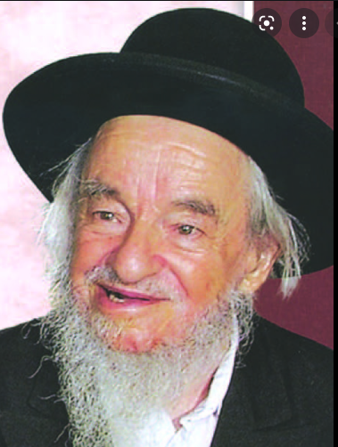
Rav Ephraim Wachsman and Rav Yaakov Galinsky

Rav Ephraim Wachsman relates that the young Yeshivah Bachrim were not the only ones who were deported to Siberia. The Russians had also imprisoned a large part of the Lithuanian government, including the parliament and many of the military leaders. The Russians took great pleasure in demoralizing the prisoners. The higher of a position a person had held in Lithuania, the more humiliating of a job he received in Siberia.
The Minister of Education of Lithuania was a brilliant man who spoke fifteen languages. He was awarded with latrine duty. All the prisoners had a tremendous amount of respect for the Yeshivah Bachrim. When the prisoners would get into arguments amongst each other, they would go to the Yeshivah Bachrim to decide their ‘Din Torahs’, as they knew the Bachrim could be trusted.

Notice a Fellow Prisoner in the
Dark Rummaging through a Bag
One night, one of the Yeshivah Bachrim, Yankele, later the well-known Maggid in Eretz Yisroel, Rav Yaakov Galinsky, zt”l, awoke to soft rustling. From the corner of his eye, he watched how a fellow prisoner awoke and was rummaging through a bag. The man took out a uniform, got dressed and stood in front of the mirror.
The night was black and he was able to see through the window’s reflection how this prisoner, dressed in a Lithuanian high-ranking uniform, started saluting, marching, and strutting back and forth for fifteen minutes. Yankele watched in fascination. Eventually, the prisoner took off the uniform, returned it to the bag under the bunk, and went back to sleep.
The next morning, Yankele approached his fellow prisoner and asked, “What was going on last night? I saw you get dressed in the middle of the darkness. What was that all about?”

A Way of Not Forgetting Who He is
The prisoner confided, “I’ll tell you the truth. I was a general in the Lithuanian army. Now, in Siberia, the Russians use every opportunity to humiliate me. I must keep reminding myself who I really am. Therefore, every night I stand in front of the mirror, put on my uniform, and I remind myself that I am an honorable general, as I march back and forth, saluting myself. That is the way that I will not forget who I am.”
Rav Wachsman said that this lesson applies to us as well. This is our Avodah in this world. We are the precious children of the Ribono Shel Olam, and we must remind ourselves of this at every opportunity!

Reprinted from the Parshas Eikev 5781 email of Rabbi Yehuda Winzelberg’s Torah U’Tefillah.

The Unintended Slighting
Of a Torah Scholar

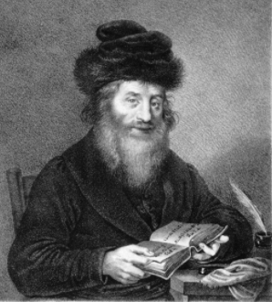

In the mid-1800’s in Hungary, a great Talmid Chacham by the name of Rav Dovid Deitsch, zt”l, a contemporary and close friend of the Chasam Sofer, Rav Moshe Schrieber, zt”l, passed away.
The Chasam Sofer was getting older, and his health was not what it used to be, and those closest to him decided not to tell him about his dear friend’s passing, so as not to distress him. Rav Dovid’s funeral was small and kept hidden from the Chasam Sofer.

Traveled to Fishtiak to Use the
Therrapeutic Baths and Hot Springs
About a month after this, the Chasam Sofer and a few of his Gaba’im, traveled to the town of Fishtiak, where the Chasam Sofer was to make use of the therapeutic baths and hot springs for his aging body. The baths in this particular place were built as small pools which were heated from inside and kept sealed with large shutters over the mouth of the pool, to retain the heat.
When a person stepped down into the bath, the shutters overhead were opened up and held up in place by hinges that supported it. The Gaba’im of the Chasam Sofer arranged for a private bath for their Rebbe, as it would be inappropriate for him to have to bathe with others around.
The Chasam Sofer was alone in the large room of pools when he entered into the hot bath. Almost immediately after he settled in, he heard a crack and looked up in dismay to see that the hinges that were supporting the large overhead shutters had slipped off its bearings and the heavy doors came crashing down onto the opening over the pool.

The Heat was Becoming Unbearable
There was nothing the Chasam Sofer was able to do to stop the doors from closing down on top of him, and in his weakened state, he was unable to lift up the shutter doors. The heat became unbearable as the steam now had no way to escape. It seemed that in a matter of minutes, he would succumb to the torturous heat.
The Chasam Sofer, unlike most others who find themselves in a desperate situation, did not panic, nor did he scream or pound on the shutters until he was drained of every ounce of his strength.
Instead, in the darkness of that narrow little pool, he closed his eyes and made a Cheshbon HaNefesh, an accounting for his Neshamah. “How could it be,” he thought to himself, “that Hashem would allow me to perish in this horrible way? What did I do to deserve that this should happen to me? Surely, this is not a coincidence.”
Right then, he remembered the words of the Gemara, which teach that if one does not properly eulogize a Talmid Chacham, he deserves to be buried alive. Being trapped in a tiny pool of water and suffocated by the heat and steam, is definitely like being buried alive!

Made a Resolve to Correct the Situation
The Chasam Sofer decided that most likely, somewhere in his life he did not correctly see to the final respects of a Talmid Chacham, and as a result of this, he had to pay for this terrible oversight with his own harsh and unusual death. He accepted upon himself, that were Hashem to spare his life, he would look into this matter and do his absolute best to correct the situation.
Suddenly, as if by magic, the heavy shutters began to creak open and lifted up back into their rightful place. The Chasam Sofer then called out, and he was rescued from the bath. That very day, he inquired and found out about the death of his good friend Rav Dovid Deitsch, and how the people around him had kept it quiet. He then assembled anyone that he could, and delivered a long and respectful Hesped for his friend!

Reprinted from the Parshas Eikev 5781 email of Rabbi Yehuda Winzelberg’s Torah U’Tefillah.
No Time for Movies

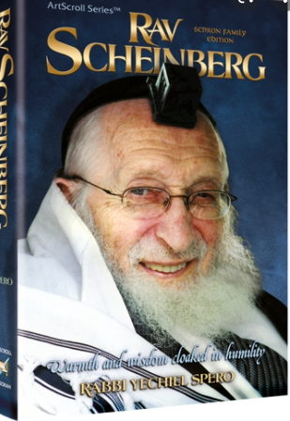s

Once, after Rav Chaim Pinchos Scheinberg ZT"L, returned from one of his numerous trips abroad, he was asked, “How was the trip?”
Rav Scheinberg smiled deeply and responded, “This time, it was an excellent flight! It was comfortable and without any interruptions!”
When asked why, Rav Scheinberg replied that as he boarded the plane, he was told that there was no seat available in the movie-free section. The airline apologized to the Rabbi but at the moment, there was nothing for them to do.
In the end, R’ Scheinberg had no choice but to sit in a place he had not planned on. Suddenly, the video system in that section broke down. Nobody’s system was working.
A technician was called but hard as he tried, he could not get the system to work. All those seated in that section were upset and went to look for other seats, leaving the Rosh Yeshivah to enjoy a quiet seating area, without any passengers (or movies) around him to disturb him.

Reprinted from the Parshas Eikev 5781 email of Mendel Berlin’s Torah Sweets Weekly.
Not an Easy Job Request
By Rabbi Yoseph Geisinsky

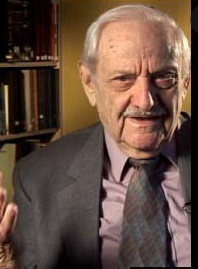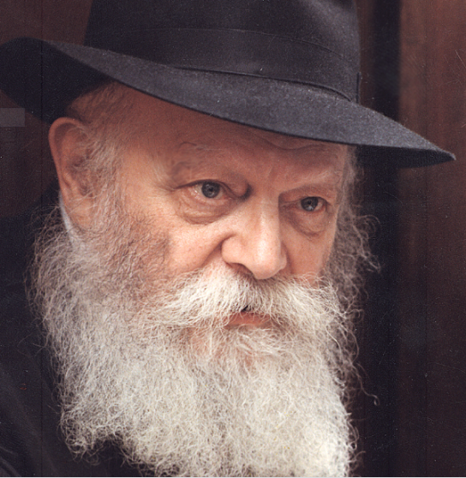
Rabbi Zev Segal and the Lubavitcher Rebbe

Rabbi Zev Segal (1917-2008), longtime president of the Rabbinical Council of America and Rabbi of Young Israel in Newark, was a renowned Jewish activist, who worked relentlessly for Jewish individuals and communities across the globe. He was a passionate Jew who traveled extensively for Jewish causes.
On one occasion, the Lubavitcher Rebbe found out that Rabbi Segal was traveling to Communist Russia and asked him to undertake a "very difficult assignment." Segal agreed and got the job done.
When he arrived back in the United States, Segal was granted a private audience with the Rebbe.
"I said that the Rebbe should know that it was not an easy task," Segal recalled.
The Rebbe responded: "Since when did you make a contract with the Master of the World for an easy life?"
Rabbi Segal said that that line stuck with him for life, and provided a lesson in how he should approach responsibilities and challenges.

Reprinted from the Parshas Eikev 5781 email of Chabad of Great Neck (NY).

Even a Heart Attack Can be A Sign of G-d’s Great Love
By rabbi Reuven Semah

Rabbi Yitzchok Hisiger tells a true story that clearly illustrates this.
A Jew from England, named Samuel, shared his story with Rabbi Biderman. A few years ago he flew from England to New York to attend a wedding of his brother’s child in Boro Park. Just as the plane landed in New York, he had a heart attack. He was taken to the hospital and spent ten days there. Because he didn’t have insurance in the United States, he racked up a medical bill of $30,000. He was devastated.
In his moment of weakness, he called out to Hashem with a question. “Hashem, the fact that you caused me a heart attack I can accept as an act from Heaven. But had that very heart attack occurred just eight hours earlier, while I was still in England, almost all of my expenses would have been covered by insurance.”
Samuel related his frustration to his Rabbi, who answered him brilliantly. “Samuel, listen to me carefully. Don’t you realize, on Rosh Hashanah it was decreed for you to spend $30,000 on medical expenses. Imagine if the heart attack had indeed occurred in England and thus not cost you very much financially. Think of how much you would have had to endure in order to reach the sum of $30,000 on medical expenses! Imagine how many doctors you would have had to visit. Imagine how many operations you would have had to undergo. Imagine how much therapy you would have had to deal with. You would have been busy with health related challenges all year! Instead, Hashem had mercy on you and sent you to New York, where you wouldn’t have insurance, and you would thus reach the necessary amount in just ten days!”
The way we view the world depends on us. We can view the $30,000 spent as a very strict event, or we can view it as a very merciful event.

Reprinted from the Parshat Ekev 5781 email of Rabbi David Bibi’s Shabbat Shalom from Cyberspace. Also published in the Jersey Shore Torah Bulletin.
|

The Secret Ceremony
By David Koppelman

In the Russian town of Brazdiuv lived an old man by the name of Reb Zalman Lichtzier. He was a professional mohel, a rarity in the Soviet Union in the 1960s. Although the government had forbidden the ritual of circumcision, Reb Zalman let it be known that he was willing to ignore the decree and circumcise any Jewish child that was brought to him. Old as he was, he felt he did not have much to lose by defying the government, for the worst they could do was execute him, and he had already lived a long and full life.
Word of this dedicated mohel spread among the Jews, and from near and far they secretly brought him their baby boys. Reb Zalman circumcised them all, and refused to accept payment for his services.
One day a “natchalnik,” a high-ranking officer, armed with a shotgun, showed up on Reb Zalman’s doorstep. Reb Zalman invited the officer into his house, sure that he was about to be arrested. Instead the officer said, “I, too, am a Jew. My wife, who is also Jewish, has recently borne me a beautiful son, and we would like you to perform his berit milah.”
Reb Zalman was struck dumb. But he did not have to answer yet, for the officer was still explaining the situation.
“It is forbidden for you, obviously a Jew, to enter my home. If you were to be seen, both of our lives would be in danger. Therefore, I worked out the following plan: You will try to cross the border at a place I will designate, without a passport. You will be arrested and brought to me, for it is my job to deal with illegal border crossings. At that point I will take you to my home, and you will perform the berit there.”
Was the officer speaking the truth, or was he trying to ensnare Reb Zalman in an elaborately set trap? Reb Zalman did not know. “I have taken upon myself to perform the misvah of berit milah with absolute mesirut nefesh,” he thought, “and so I will take a chance and follow the officer’s instructions, although I may be risking my life.” He hoped his decision was the right one.
Reb Zalman acquiesced to the officer’s plan. He took a valise and packed his talet, tefillin, and the instruments he would need for the milah, and traveled towards the agreed-upon border point. According to plan, he was arrested, admitted to not having a passport, and then taken directly to the Jewish officer who had come to see him. The officer, playing his part to perfection, angrily yelled that he would punish the Jew as he deserved. As soon as the arresting officer left, the “natchalnik” seated Reb Zalman in his car and drove him to his home.
The berit milah was carried out according to halachah, and after it was all over, the officer drove Reb Zalman back to Bradziuv, where he continued to perform his secret misvot. (Glimpses of Greatness)

Reprinted from the Parshat Ekev 5781 email of Rabbi David Bibi’s Shabbat Shalom from Cyberspace. Also published in the Jersey Shore Torah Bulletin.

The Kind Benefactor Who Was Barred From Heaven
By Hillel Baron

The rabbi of Krakow, Rabbi Yoel Sirkes (1560-1640), known as “the Bach,”¹ had a wealthy disciple whom the Bach taught to be generous with the gifts G-d had bestowed upon him.
One day, an innkeeper complained to the Bach that someone was trying to wrest the lease of his inn for himself, offering the landowner larger sums of money. If he succeeded, the innkeeper’s livelihood would be decimated.
The Bach called for his wealthy student and shared the innkeeper’s plight. The disciple knew the landowner, and agreed to intercede to ensure he would not lease the inn to anyone else. First, however, he had to travel to the grand fair in Leipzig. Afterwards, he would head to the innkeeper’s town and attend to the matter.
The innkeeper begged him to take care of his matter first. He worried that by the time the merchant returned, he would have already lost his home and his source of income.
The wealthy man sat the distraught innkeeper down, and told him that he had to bolster his faith. “You don’t need to help G-d with your calculations,” he said. “G-d will take care of you. Have no fear.”
When the innkeeper came home and told his wife the plan, she was completely distraught and berated her husband for letting the man delay his assistance.

Art by Yitzchok Schmukler

In the end, however, it all turned out for the best. When the wealthy man returned from the fair, he traveled to the innkeeper’s town, spoke to the landowner, arranged for the innkeeper to retain his lease, and elicited a guarantee that the landowner would not lease the inn to anyone else for the coming ten years.
The innkeeper and his wife were relieved, overjoyed, and immensely grateful.
Many years later, the wealthy disciple passed away, predeceasing his teacher. He appeared to the Bach in a dream, and said that he wished to convey what had happened to him when he arrived in Heaven:
“After my case was heard by the Heavenly Court, I was thankfully judged favorably, and brought into Gan Eden. The aroma of Gan Eden was like nothing I had ever smelled, and all I felt was goodness.

“Suddenly, I saw an angel walking toward me. It blocked my way forward, and began to drag me back out of Gan Eden!
“I asked: ‘Who are you? And why are you taking me out of this wonderful place?’
“He said: ‘I am the angel created by your mitzvah of saving the innkeeper and his family from financial ruin. But you have no idea how many tears, how much heartbreak, and the amount of marital strife you caused by delaying your help until you got back from the fair.’
“The angel brought me back to the Heavenly Court, who ruled that I would need to wait at the gates of Gan Eden for the same amount of time I had made the innkeeper wait until I helped him.
“I wanted to convey this story to you so that others can be taught about the importance of not delaying assistance to those in need,” the wealthy man’s soul concluded.
Do we have an opportunity to help someone? And if we do, are we doing it at the earliest possible time?

FOOTNOTES
1. An abbreviation of the name of his commentary on the Shulchan Aruch, “Bayit Chadash.”

Reprinted from the Parshat Re’eh 5781 email of Chabad.Org Magazine.

